Ahmed’s App

discription: this app adds a field on sales order.

1. Select one or multiple products in Restrict Products and then tick Product Restriction boolean.

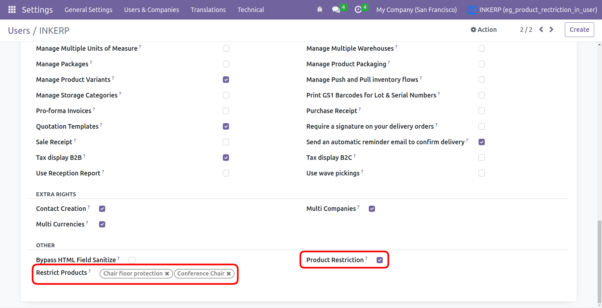
2.Here you can seethat restricted products is disappear in products. (to visiable the restricted products untick the product restriction boolean)

